**MOTION CONTROLLED LED**



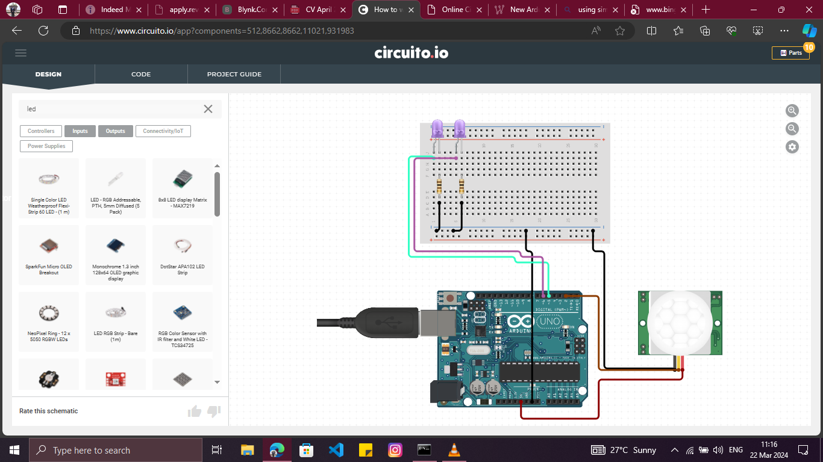

**TEMPERATURE AND HUMIDITY METER**



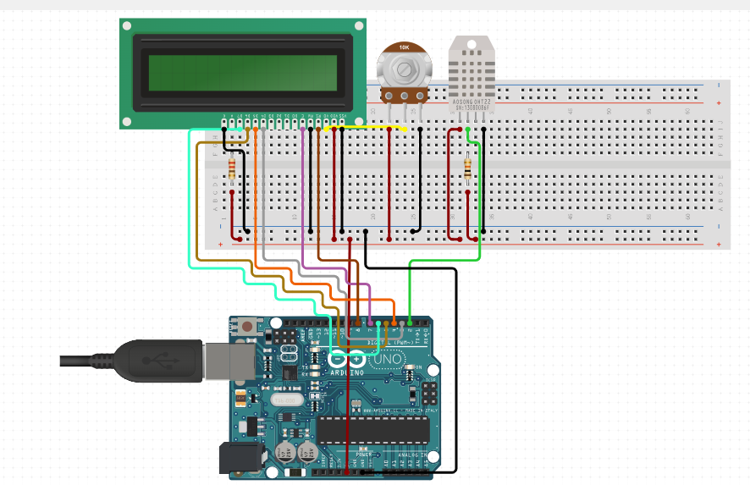

**Sound CONTROLLED LED**



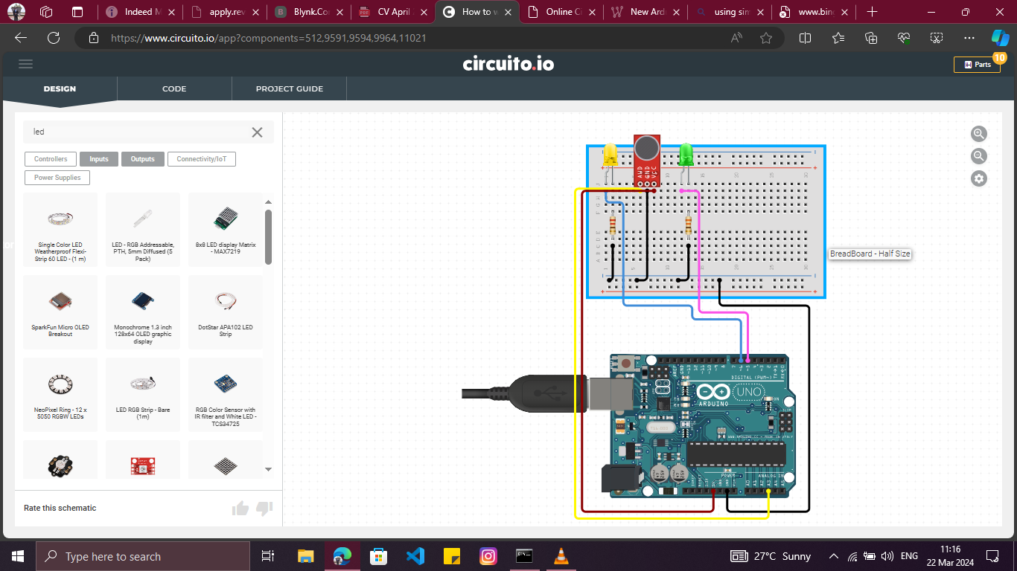

**2 WAY TRAFFIC LIGHT SYSTEM**



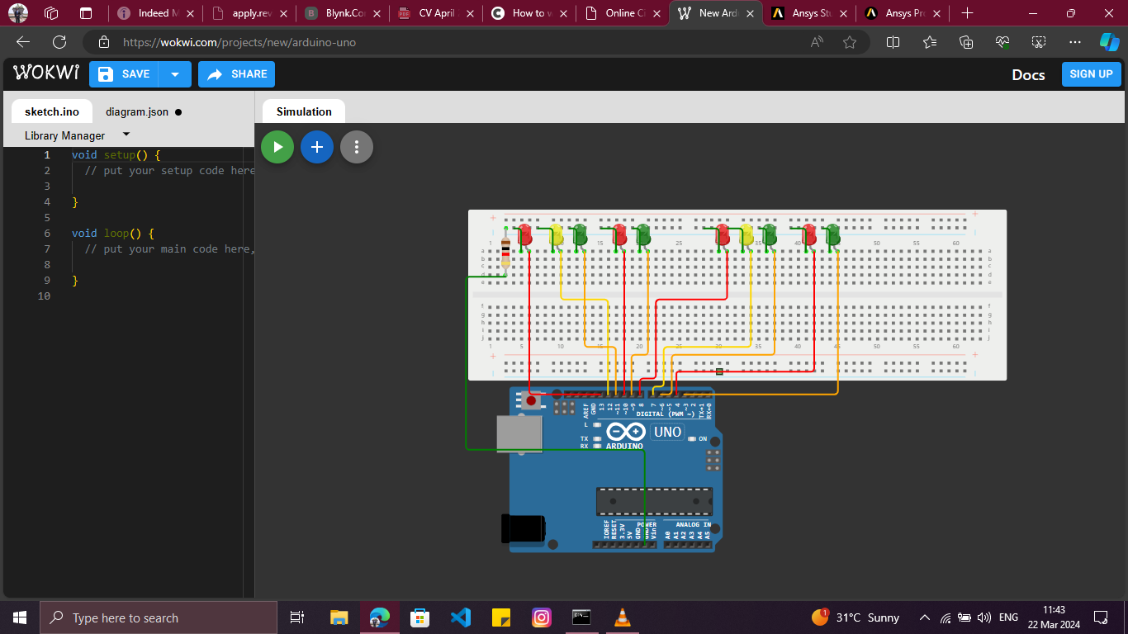

**RFID LOCK SYSTEM**



